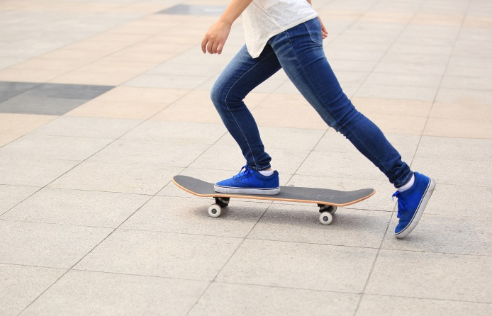Student worksheet

7.1 A force is a push or a pull

Pages 120–121 and 202

Push and pull forces

1 Forces act on everything around us all the time. Although these forces cannot be seen, their effect can be observed. In the spaces provided, draw a labelled diagram to explain what forces cause objects to do. (Use a different example from the ones in the textbook.)

|  |  |
| --- | --- |
| **Begins to move** | **Speeds up** |
| **Slows down** | **Changes direction** |
| **Changes shape** | **Remains still** |

2 Write the definitions for the following words to help you revise some terms that you have encountered in previous chapters and also revise the new words:

a Force

b Gravity

c Spring balance

d Calibrated

e Newton

EXTEND YOUR UNDERSTANDING

3 Research the forces involved in one of your favourite sports (e.g. kicking a football in AFL or stopping suddenly in netball).

Student worksheet

7.2 An unbalanced force causes change

Pages 122–123 and 203

Balanced and unbalanced forces

Force diagrams can be used to represent the direction and strength of a force. A short arrow shows a weak force, whereas a long arrow indicates a strong force.

1 The diagrams below show the force acting on a block. Beside each diagram, write whether the force is *balanced* or *unbalanced.*

|  |  |  |
| --- | --- | --- |
| a | WS0701_00883 |  |
| b | WS0701_00883 |  |
| c | WS0701_00883 |  |

The direction of the force can also be determined by looking at the length of the arrows and the direction the arrow is pointing.

2 The diagrams below show the force acting on a block. Under each diagram, draw an arrow to indicate the direction that the block would travel.

|  |  |  |
| --- | --- | --- |
| a | WS0702_00883 |  |
| b | WS0702_00883 |  |
| c | WS0702_00883 |  |

The net force can also be worked out by looking the length and direction of the arrows and the newtons of force. If the forces are in the *same* direction, they can be added together. If the forces are in *opposite* directions, they can be subtracted.

3 The diagrams below show the force acting on a block. Under each diagram, draw an arrow to indicate the direction the block would travel and calculate the amount of force (in newtons) acting on the object.

|  |  |  |
| --- | --- | --- |
| a | WS0703_00883 | Net force = \_\_\_\_\_\_\_\_\_\_\_N |
| b | WS0703_00883 | Net force = \_\_\_\_\_\_\_\_\_\_\_N |
| c | WS0703_00883 | Net force = \_\_\_\_\_\_\_\_\_\_\_N |

EXTEND YOUR UNDERSTANDING

4 Investigate a place you know (e.g. your home or a relative’s house). Write five examples of unbalanced forces that you experience at this location.

Student worksheet

7.3 Forces can be contact or non-contact

Pages 124–125 and 203

Magnetic force

1 Magnets are an example of a non-contact force. What does this mean?

2 a Magnets are made of an alloy. What is an alloy?

b The main metal in most magnetic alloys is \_\_\_\_\_\_\_\_\_\_\_\_\_\_\_\_\_\_\_\_\_\_\_\_\_\_\_\_\_\_\_\_.

3 On each of the diagrams below, write if the force between the magnets is an *attraction* or a *repulsion*. Include an arrow to indicate the direction of the force.

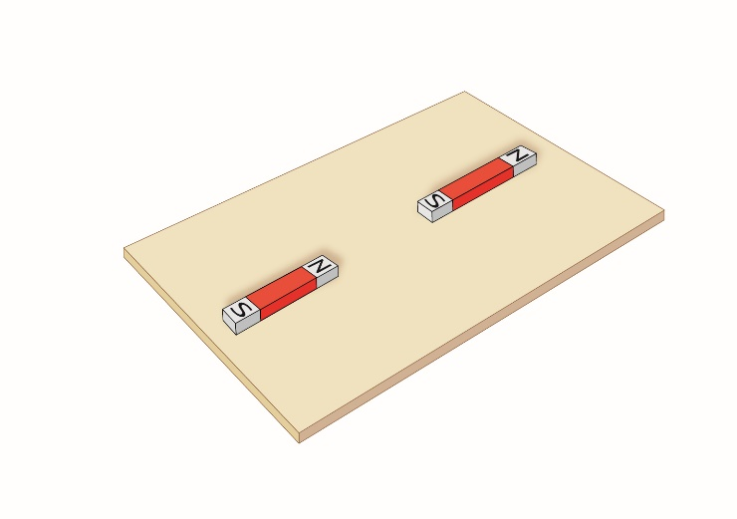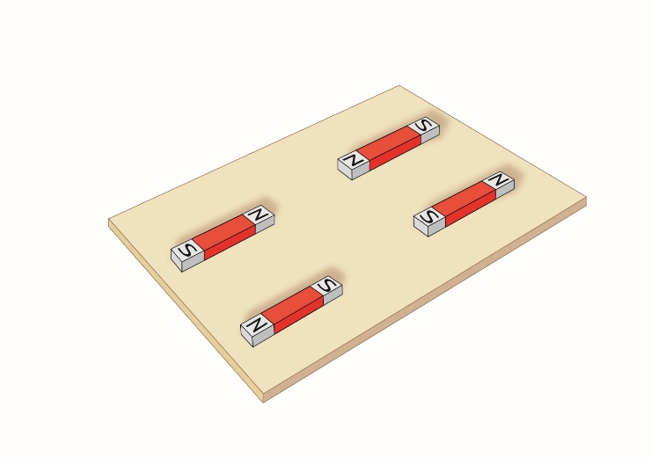

EXTEND YOUR UNDERSTANDING

4 Find out about another four possible applications of Maglev technology.

Student worksheet

7.4 Magnetic fields can apply a force from a distance

Pages 126–127

Magnetic fields

1 Magnetic fields can be shown by scattering iron filings around a bar magnet.

a Why are iron filings used to show magnetic fields?

b Magnetic field lines should point away from the north and towards the south. Draw a map of the magnetic field lines on the second magnet.

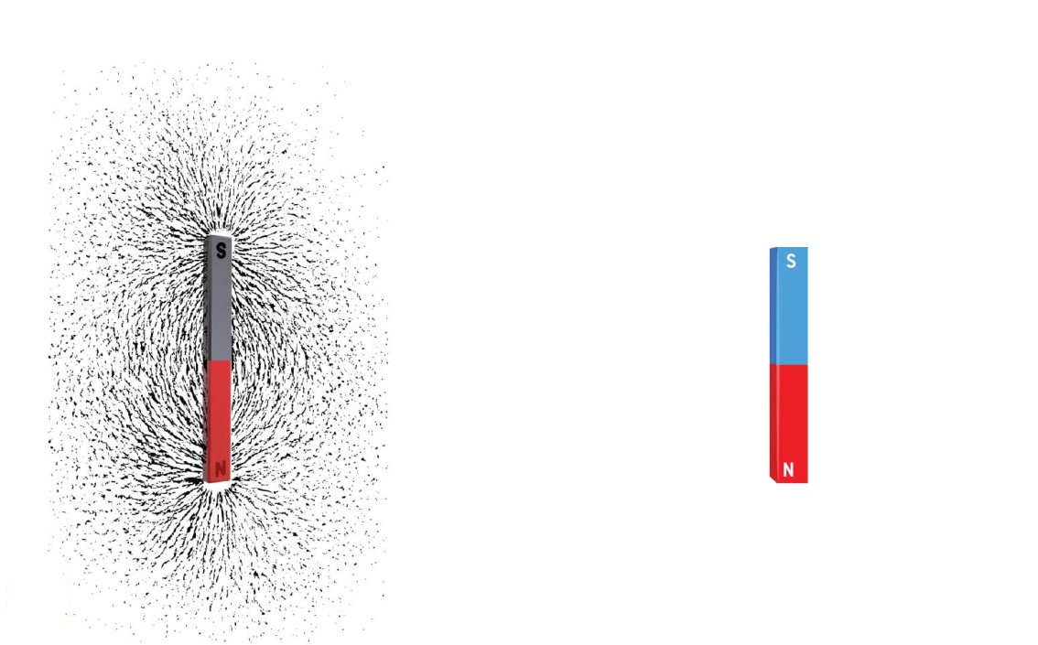

c Draw a map of the magnetic field lines on the magnet below.

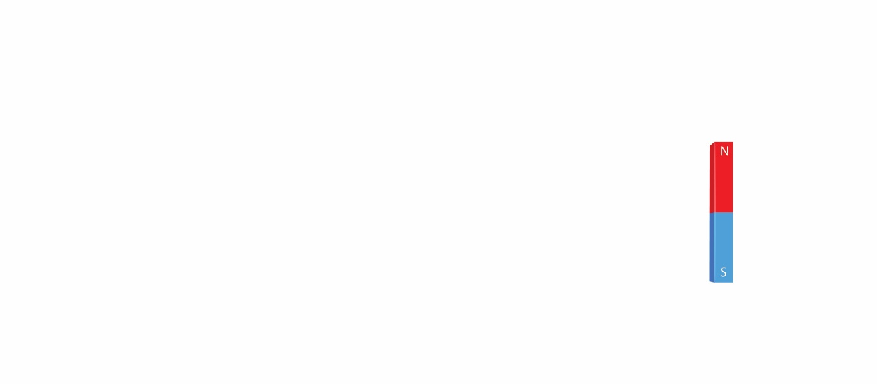

2 The Earth is like an enormous magnet with its own north and south poles.

a What is the difference between the Earth’s magnetic pole and the Earth’s geographic pole?

b Draw magnetic field lines on the diagram of the Earth below.

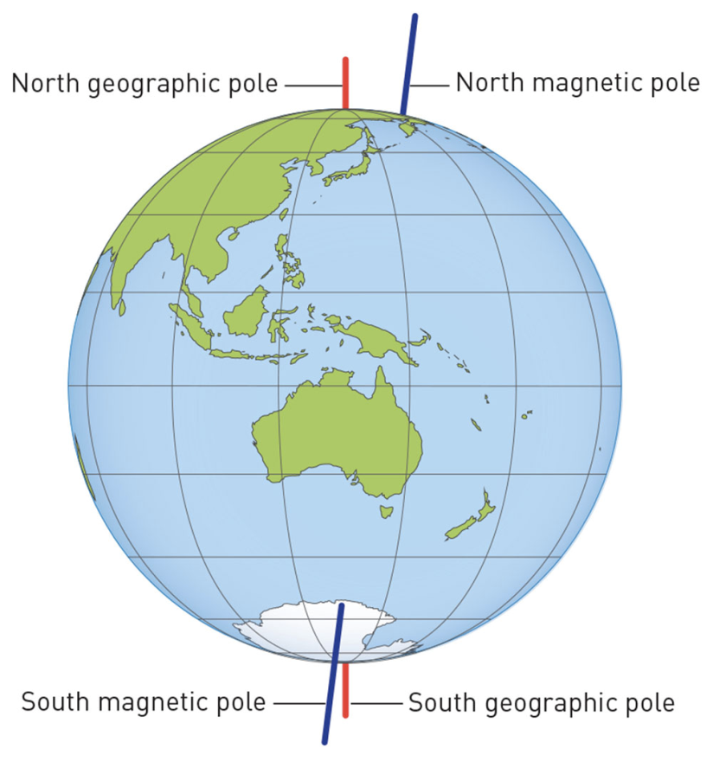

EXTEND YOUR UNDERSTANDING

3 The Earth’s magnetic fields affect various natural phenomena, from turtles navigating their way through the ocean to the majestic light show of the auroras. Research another animal that uses magnetic fields to help it navigate or find out more about the formation of the auroras.

Student worksheet

7.5 Electrostatic forces are non-contact forces

Pages 128–129 and 204

Static electricity

1 In each of the scenarios below, write whether the objects will *attract, repel* or *do neither*.

a Two negatively charged objects: \_\_\_\_\_\_\_\_\_\_\_\_\_\_\_\_\_\_\_\_\_\_\_\_\_.

b Two positively charged objects: \_\_\_\_\_\_\_\_\_\_\_\_\_\_\_\_\_\_\_\_\_\_\_\_\_.

c A positively charged object and a negatively charged object: \_\_\_\_\_\_\_\_\_\_\_\_\_\_\_\_\_\_\_\_\_\_\_\_\_.

d A positively charged object and a neutral object: \_\_\_\_\_\_\_\_\_\_\_\_\_\_\_\_\_\_\_\_\_\_\_\_\_.

e A negatively charged object and a neutral object: \_\_\_\_\_\_\_\_\_\_\_\_\_\_\_\_\_\_\_\_\_\_\_\_\_.

f Two neutral objects: \_\_\_\_\_\_\_\_\_\_\_\_\_\_\_\_\_\_\_\_\_\_\_\_\_.

2 Complete the following sentence about the creation of electrostatic charges.

When objects are \_\_\_\_\_\_\_\_\_\_\_\_\_\_\_\_\_\_\_\_\_\_\_\_\_ they become \_\_\_\_\_\_\_\_\_\_\_\_\_\_\_\_\_\_\_\_\_\_\_\_\_ because they have \_\_\_\_\_\_\_\_\_\_\_\_\_\_\_\_\_\_\_\_\_\_\_\_\_ or gained \_\_\_\_\_\_\_\_\_\_\_\_\_\_\_\_\_\_\_\_\_\_\_\_\_.

If they are placed near neutral objects (which have \_\_\_\_\_\_\_\_\_\_\_\_\_\_\_\_\_\_\_\_\_\_\_\_\_ positive and \_\_\_\_\_\_\_\_\_\_\_\_\_\_\_\_\_\_\_\_\_\_\_\_\_ charges) they will be \_\_\_\_\_\_\_\_\_\_\_\_\_\_\_\_\_\_\_\_\_\_\_\_\_ to the \_\_\_\_\_\_\_\_\_\_\_\_\_\_\_\_\_\_\_\_\_\_\_\_\_ charges and will move \_\_\_\_\_\_\_\_\_\_\_\_\_\_\_\_\_\_\_\_\_\_\_\_\_ that object.

This attraction or \_\_\_\_\_\_\_\_\_\_\_\_\_\_\_\_\_\_\_\_\_\_\_\_\_ force due to charges is called \_\_\_\_\_\_\_\_\_\_\_\_\_\_\_\_\_\_\_\_\_\_\_\_\_ electricity.

3 a In the space on the following page, draw a simple sketch to show what you would look like if you were touching a Van de Graaff generator.

b Add labels to the diagram to answer the following questions:

i Where do the charges come from that build-up on the dome?

ii Why are the charges attracted to nearby objects?

iii What causes your hair to stand up on end?

iv Why would you need to stand on a rubber mat?

|  |
| --- |
|  |

EXTEND YOUR UNDERSTANDING

4 Research who invented the Van de Graaff generator. Write a short biography of the inventor and find out whether the inventor made any other discoveries.

Student worksheet

7.6 Friction slows down moving objects

Pages 130–131 and 205

Friction

1 Fill in the gaps to complete this summary of friction:

Friction is a \_\_\_\_\_\_\_\_\_\_\_\_\_\_\_\_\_\_\_\_\_\_ force. It works when the surface of one object \_\_\_\_\_\_\_\_\_\_\_\_\_\_\_\_\_\_\_\_\_\_ against the \_\_\_\_\_\_\_\_\_\_\_\_\_\_\_\_\_\_\_\_\_\_\_ of another object. The greater the area of \_\_\_\_\_\_\_\_\_\_\_\_\_\_\_\_\_\_\_\_\_\_ between surfaces, the greater the friction. Friction acts in the opposite direction to \_\_\_\_\_\_\_\_\_\_\_\_\_\_\_\_\_\_\_\_\_\_. The \_\_\_\_\_\_\_\_\_\_\_\_\_\_\_\_\_\_\_\_\_\_ the surface, the less (or more) friction there is and the \_\_\_\_\_\_\_\_\_\_\_\_\_\_\_\_\_\_\_ an object can move. Friction can generate \_\_\_\_\_\_\_\_\_\_\_\_\_\_\_\_\_\_\_\_\_ when objects are moving: the greater the friction, the \_\_\_\_\_\_\_\_\_\_\_\_\_\_\_\_\_\_\_\_\_\_\_ the heat made.

2 Describe a situation when there is too much friction.

3 Describe a situation when there is too little friction.

4 Study the diagrams of different surfaces. Rank the surfaces from 1 (least frictional force) to 4 (least frictional force).

|  |  |  |  |
| --- | --- | --- | --- |
| Carpet | Rocks | Ice | Wet grass |
| WS0709_00883-rf | WS0710_00883-rf | WS0711_00883-rf | WS0712_00883-r |

5 Explain two different methods you could use that would allow you to *push* a heavy boulder across the ground.

6 Using the concept of friction, why is it useful that we produce saliva as we chew our food?

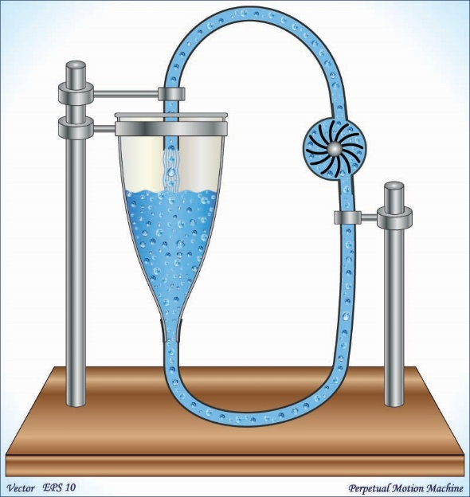EXTEND YOUR UNDERSTANDING

7 The device pictured here is a perpetual motion machine. Using your understanding of friction combined with research from the Internet, explain whether this machine is possible.

Student worksheet

7.7 Simple machines decrease the amount of effort needed to do work

Pages 132–133 and 206–207

Simple machines

The Ancient Egyptians applied their knowledge of forces to help them develop simple machines to aid in the construction of the pyramids.

1 The three images below show the methods the Egyptians used. For each image, identify the simple machine used and discuss how this machine was used to increase the amount of force.

|  |  |  |
| --- | --- | --- |
| a | L:\1. Publishing and Editorial\1. Product\Oxford Science\Oxford Science 7\3. Extras\7. Student worksheets\Artwork\4. Final jpgs\from Perms\WS0714_00883-r.jpg |  |
| b | L:\1. Publishing and Editorial\1. Product\Oxford Science\Oxford Science 7\3. Extras\7. Student worksheets\Artwork\4. Final jpgs\from Perms\Edited artwork from Julia\Chapter 7\JPEGs\WS0715_00883-r.jpg |  |
| c | L:\1. Publishing and Editorial\1. Product\Oxford Science\Oxford Science 7\3. Extras\7. Student worksheets\Artwork\4. Final jpgs\from Perms\WS0716_00883-rf.jpg |  |

2 Levers allow us to lift and move loads that are heavier than we could actually pick up using just our body. Below are diagrams of the three classes of lever. For each diagram:

• identify the class of the lever

• label the fulcrum, load and the direction of the effort

• draw an example (different from those in the textbook) of this type of lever.

|  |  |  |
| --- | --- | --- |
| a | L:\1. Publishing and Editorial\1. Product\Oxford Science\Oxford Science 7\3. Extras\7. Student worksheets\Artwork\4. Final jpgs\from Perms\Edited artwork from Julia\Chapter 7\JPEGs\WS0717_00883-r.jpg |  |

|  |  |  |
| --- | --- | --- |
| b | L:\1. Publishing and Editorial\1. Product\Oxford Science\Oxford Science 7\3. Extras\7. Student worksheets\Artwork\4. Final jpgs\from Perms\Edited artwork from Julia\Chapter 7\JPEGs\WS0718_00883-r.jpg |  |

|  |  |  |
| --- | --- | --- |
| c | L:\1. Publishing and Editorial\1. Product\Oxford Science\Oxford Science 7\3. Extras\7. Student worksheets\Artwork\4. Final jpgs\from Perms\Edited artwork from Julia\Chapter 7\JPEGs\WS0719_00883-r.jpg |  |

3 Because levers allow people to lift and move heavy loads, they give people a ‘mechanical advantage’. The mechanical advantage can be calculated by dividing the size of the load (in newtons) by the size of the effort (in newtons). For example, if a wheelbarrow contains a 3 N load and it requires 1 N of effort to lift, the mechanical advantage is 3 divided by 1, which equals 3. Work out the mechanical advantage in the following situations:

a A boulder has a 10 N load and requires 5 N of effort to move it using a lever. What is the mechanical advantage of the lever?

Mechanical advantage = \_\_\_\_\_\_\_\_\_\_\_\_\_\_\_\_\_\_\_\_\_\_\_\_\_\_\_

b A nail had a 9 N load of resistance and requires 3 N of effort using a hammer to remove it. What is the mechanical advantage of the hammer?

Mechanical advantage = \_\_\_\_\_\_\_\_\_\_\_\_\_\_\_\_\_\_\_\_\_\_\_\_\_\_\_

c A washing machine has a 600 N load and requires 200 N of effort to move it using a trolley. What is the mechanical advantage of the trolley?

Mechanical advantage = \_\_\_\_\_\_\_\_\_\_\_\_\_\_\_\_\_\_\_\_\_\_\_\_\_\_\_

EXTEND YOUR UNDERSTANDING

4 Research some of the simple machines that were used by the Ancient Romans or Greeks during the construction of their societies. Try to find an example of a first-, second- and third-class lever used by these societies.

Student worksheet

7.8 A pulley changes the size or direction of force

Pages 134–135 and 208

Pulleys

1 The diagrams below depict various situations where pulley systems are helping the person lift bigger loads. For each of the situations, fill in the missing information as required:

• how far the mass would be raised (D)

• the force required (F)

• the length of the rope (L)

• the mechanical advantage (M)

For example, in a single-pulley system the mechanical advantage is 1. To lift a mass of 100 kg, you have to pull down with a force equivalent to 100 kg. To raise the 100 kg mass 1 m into the air, you have to pull the rope a total distance of 1 m at the other end.

|  |  |  |  |
| --- | --- | --- | --- |
| a | WS0720_00883-r | b | WS0721_00883-r |
| c | WS0722_00883-r | d | WS0723_00883-r |
| e | WS0724_00883-r | f | WS0725_00883-r |

EXTEND YOUR UNDERSTANDING

2 Archimedes, the Greek scientist and mathematician who developed the pulley, also developed a machine known as Archimedes’ screw. Use the Internet to conduct research and answer the following questions:

a What was this simple machine was used for?

b How does it work?

c Is it still used today?

Student worksheet

7.9 There are different types of machines

Pages 136–137 and 208

Types of machines

1 Look at the ramps in the two images below.

|  |  |
| --- | --- |
| WS0726_00883-rf | WS0727_00883-rr |

Which ramp do you think would take the least amount of effort to walk up? Explain your answer.

2 Explain how your front teeth (incisors) act as a wedge when you bite into a carrot or apple.

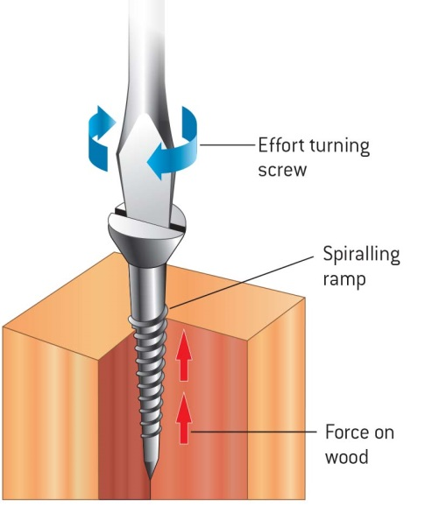

3 You may have come across the saying ‘righty tighty, lefty loosey’.

a Look at the diagram of a screw being screwed into a piece of wood to explain the meaning of this saying.

b If you were turning the screw in a clockwise direction, would you be using more or less force than turning it in an anti-clockwise direction?

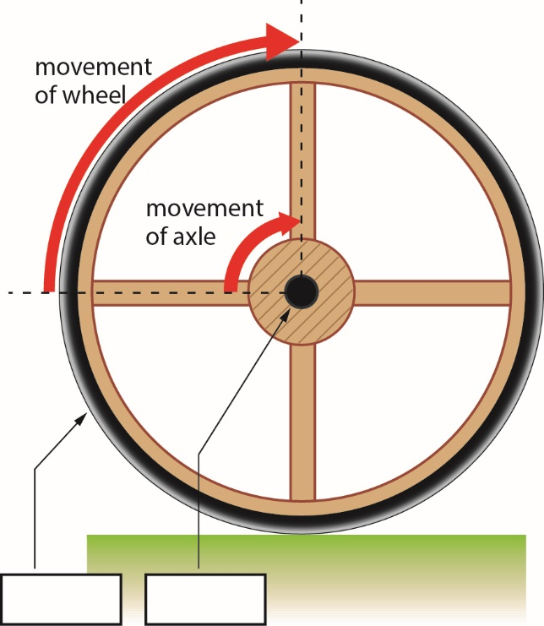

4 a Label the following features on the diagram:

• wheel

• axle

b How is this wheel a distance magnifier?

EXTEND YOUR UNDERSTANDING

5 We are often told that cavemen invented the wheel, but this is not the case. Research which society invented the wheel. Write a 100 word summary of your findings and include how the wheel was used.

Student worksheet

7.10 Science as a human endeavour: Forces are involved in sport

Pages 138–139

Forces in the body and sport

Forces in swimming

1 Why do many swimmers shave all their body hair before a competition?

2 What is the most efficient body position for a swimmer?

3 Describe the features of the full-body ‘smart suits’ that provided an advantage to the swimmers wearing it.

Forces in tennis

4 Label the parts of the tennis player’s body that provide the fulcrum, effort and load.



5 How do tennis racquets help produce greater speed and force?

Forces in golf

6 Add information to the diagram below to help explain why golf balls have dimples.

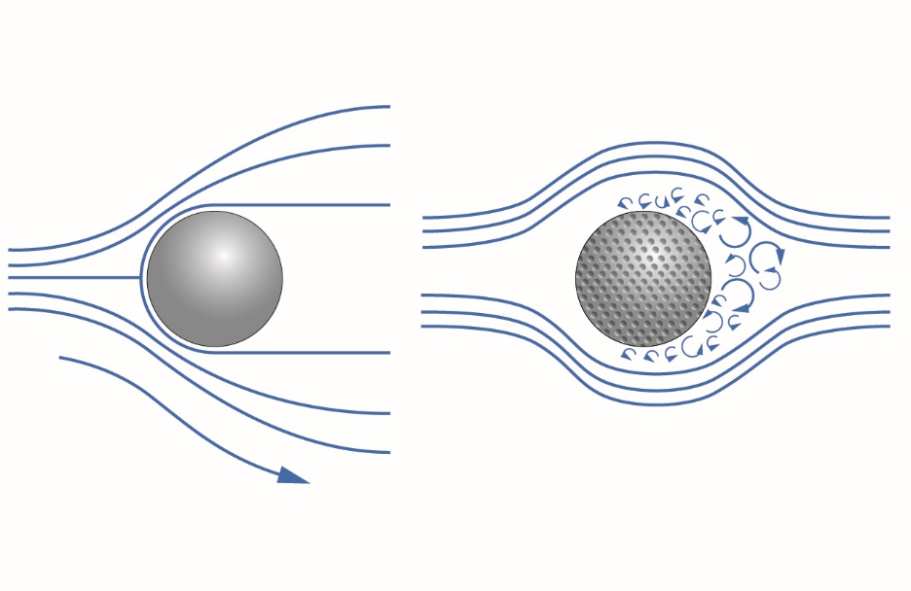

EXTEND YOUR UNDERSTANDING

7 Use the Internet to find out about kinematics. Answer the following questions:

• What is kinematics?

• Why is kinematics useful when analysing different sports?

• What sort of technology is used to gather kinematic data?

• How could kinematics be used to improve your performance when you play your favourite sport?